**DEPARTMENT OF MECHANICAL ENGINEERING  
  
Subject: Fundamentals of Programming  
LAB TASK  
Submitted by: ZAHOOR AZAM  
Registration number: 453972  
Semester No. 1  
Date: October 19, 2023**

**FIRST PROGRAM**

#include<iostream>

using namespace std;

int main(){

int n,m ,sum=0;

cout<<"Enter ten numbers"<<endl;

for(m=1; m<=10; m++)

{

cin>>n;

sum=sum+n;

}

cout<<"sum of ten numbers"<<sum;

return 0;

}

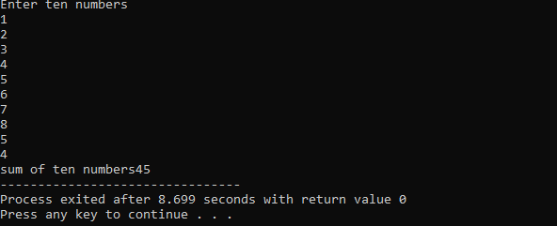

**SECOND PROGRAM**

#include<iostream>

using namespace std;

int main(){

int i=0;

int table=4,multiply;

while(i<11){

cout<<"4x"<< i<<"="<<table*i<<endl;

i++;

}

return 0;

}

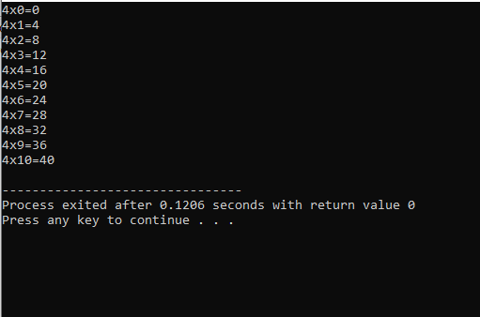

**THIRD PROGRAM**

#include<iostream>

using namespace std;

int main(){

int n, f=1;

cout<<"Enter number to calculate factorial ";

cin>>n;

for(int i=n ; i>=1 ; i--)

{

f=f*i;

}

cout<<"factorian of "<<n<<" is: "<<f;

return 0;

}

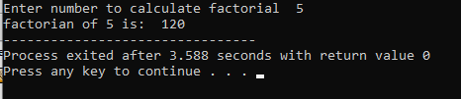

**FOURTH PROGRAM**

#include <iostream>

using namespace std;

int main() {

int n;

cout << "Enter the number of terms: "<<endl;

cin >> n;

int a = 0;

int b = 1;

cout << "The Fibonacci sequence is: "<<endl;

for (int i = 0; i < n; i++) {

cout << a << " ";

int temp = a;

a = b;

b = temp + b;

}

cout << endl;

return 0;

}

